Housing Stabilization Services Training for Coordinated Entry
Housing Stabilization Services is a new Minnesota Medical Assistance benefit to help people with disabilities, including mental illness and substance use disorder, and seniors find and keep housing.
To be eligible for the service, an individual needs to be a Medical Assistance recipient and age 18 or older. Beyond this, there are three basic eligibility criteria: a disability or disabling condition, housing instability and assessed need for services.
There are 5 questions that have been developed by the Department of Human Services that aligns with the other assessment pathways onto our service: MnChoices and the Professional Statement of Need. These questions ask about housing instability and assessed need as part of eligibility requirements for these services. All people who receive a Coordinated Entry assessment must have responses to these questions. Responses to these questions are used to generate the assessment document that a person will need for these services.

Coordinated Entry Questions

Based on their experience with the person, Coordinated Entry assessors review the following 5 questions and use their professional judgement when selecting responses. You should not ask these questions of the person, instead they should be based on observations you’ve had during the assessment. A response option is available if an assessor is unable to answer the question.

Housing Instability
Question: Is the person experiencing housing instability?
Answers: Yes /No / Unable to answer
Yes indicates person has reported their current housing situation as one of the following:
• Homeless (the person lacks a fixed, adequate nighttime residence)
• At risk of homelessness (the person is faced with a situation that may cause them to become homeless)
• Transitioning or recently transitioned from an institution, licensed, or registered setting

Communication
Question: Does this person need support communicating their needs to help with housing?
Answers: Yes /No / Unable to answer
Examples of Yes responses may include:
• Person is difficult for most listeners to understand
• Person uses non-speech method (e.g., sign language, symbols, gestures) to communicate

Mobility
Question: Does this person need support getting around to help with housing?
Answers: Yes /No / Unable to answer
Examples of Yes response may include:
• Person needs assistance or supervision to use transportation
• Person walks with physical assistance from another person
• Person does not typically walk
• Person requires assistance from another person to complete tasks requiring fine motor skills such as reading, writing, or maintaining personal care
• Person cannot walk for long periods without taking breaks

Decision Making
Question: Does this person need support in decision making related to their housing?
Answers: Yes /No / Unable to answer
Examples of Yes response may include:
• Person has reported significant short-term memory issues or confusion retaining or recalling recent events, experiences, skills, or information.
• Person shows confusion or disorientation when asked about themselves
• Person cannot weighs positives and negatives of issue in order to make appropriate decision.
• Person is easily coerced into decisions that may not benefit them.

Managing Challenging Behaviors
Question: Does this person need support managing challenging behaviors to help with housing?
Answers: Yes /No / Unable to answer
Examples of Yes response may include:
• Person exhibits behaviors that may require supports to prevent/mitigate breaking the law
• Person would have difficulty to identify and problem-solve to take appropriate action without assistance in a potentially harmful situation
• Person requires the availability of an identified/dedicated person to safely direct own activities and manage personal responsibilities

Housing Stabilization Assessment Document
The Housing Stabilization assessment document will be available within HMIS and does not require an additional report nor export of the data to generate the file. Once data is entered, this document can be immediately printed or saved as PDF to be shared with the client. The PDF can be sent to an email address or stored in their “Vault” on HB101.org.
In addition to this document, a person will still need proof of disability and a person-centered plan to meet the all of the eligibility criteria. Assessors and other Coordinated Entry staff can direct people to get in touch with their targeted or waiver case manager to complete their plan.
If someone doesn’t have a targeted or waiver case manager, you can direct them to an enrolled Housing Consultant who can complete their plan. You can locate enrolled Housing Stabilization Services providers in your area by visiting the Minnesota Health Care Programs Provider Directory, searching under Home and Community Based Services as the “type” and Housing Stabilization Services as the “subtype.”
The “Assessment Print Details” show who the person is, when the questions were answered and who the provider was that completed the assessment.
The “Coordinated Entry Assessment Question for Housing Stabilization” section shows how the questions were answered. If yes to the question regarding housing instability, and yes to any of the remaining questions, the individual meets the assessed Need and Housing Instability requirements for Housing Stabilization Services.

Example of Housing Stabilization Assessment Document:
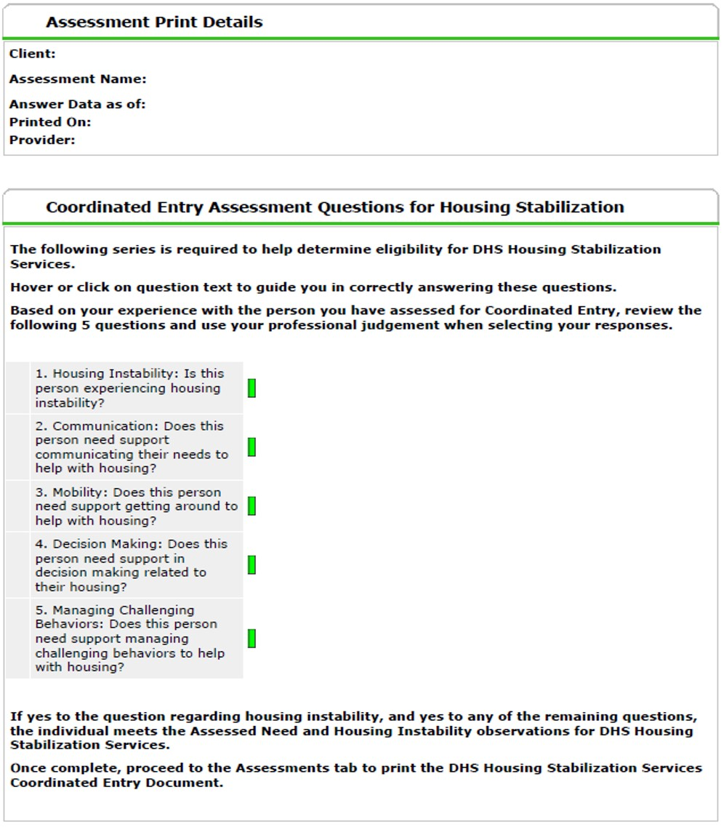

Best Practice Scenario: Jorge
Jorge is a homeless 68 year old with a traumatic brain injury who lives in an encampment near a major highway in St. Paul. Sometimes he sleeps at shelters, but when he can’t get in he relies on a couple of friends that let him sleep on their couch. Jorge has a full time job, but finds it hard keeping his work life in order without a home to return to at the end of the day. Due to his injury, he has memory loss and has trouble keeping dates and times organized. This gives him constant anxiety, and at times severe headaches and panic attacks when he feels overwhelmed.
As you work through the Coordinated Entry assessment with him, he can’t answer some of the questions because he can’t remember or finds it hard to provide an accurate response. He tells you he often relies on friends or family to help him with his work schedule and paying cell phone bills.
Based on what you have observed, Jorge would meet the criteria for housing instability and assessed need. You would answer “Yes” to housing instability because he currently lives in a shelter or doubled up with someone. You would answer “Yes” to “Does this person need support in decision making related to their housing?” because of his memory loss and reliance on others for maintaining some of his day to day activities.
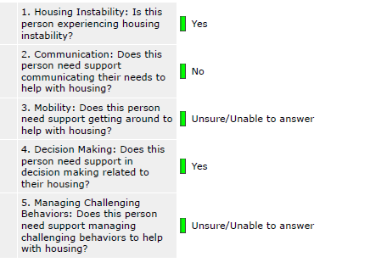

You can give this assessment document to Jorge as a hard copy that you printed off, or save it as a PDF that you can send to him via email or store in a free “Vault” account on HB101.org. It’s important to tell Jorge the next steps he needs to take to become eligible for these services.
In addition to this assessment document, Jorge will still need proof of disability and a person-centered plan to meet the all of the eligibility criteria. Since he is over 65 years old, he would automatically meet the proof of disability criteria. You can ask him if he has a waiver or targeted case manager. If he does, he will work with them to complete the plan and get connected to a Housing Stabilization provider.
If Jorge doesn’t have a waiver or targeted case manager, an enrolled Housing Consultant can work with Jorge to get develop a housing focused person-centered plan. You can look up enrolled Housing Consultants in your area using the MHCP provider directory who can work with Jorge.
For more information about these services, visit the Housing Stabilization Services policy page. It contains program announcements, policy requirements, resources and training documents.

